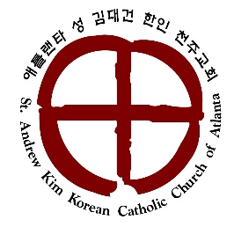
Media Release Form 2017-2018
St. Andrew Kim Korean Catholic Church of Atlanta
2249 Duluth HWY, Duluth, GA 30097

I hereby grant permission to include student phone number, address, and email address on catechist roaster.

I also hereby give my consent to all photographs, audio recordings, work, and/or video recordings taken of my child/children by St. Andrew Kim Korean Catholic Church of Atlanta. I understand that any such photographs, audio recordings, work, and/or video recordings may be used by St. Andrew Kim Korean Catholic Church of Atlanta in any and all broadcast and electronic media formats now existing or in the future created. Common examples of usage would be posting a photo taken during church events in the parish bulletin or on its website.

I acknowledge that the St. Andrew Kim Korean Catholic Church of Atlanta’s web site content is not private and can be reviewed, copied, downloaded, and transmitted by anyone with access to the Internet and that St. Andrew Kim Korean Catholic Church of Atlanta has no control over any third party or outside viewers. I hereby waive, release, and forever discharge any and all claims, demands, or causes of action against St. Andrew Kim Korean Catholic Church of Atlanta from the publishing or posting of information on the St. Andrew Kim Korean Catholic Church of Atlanta’s all forms of broadcast and electronic media, including but not limited to Internet website.

Name of Child 1: __________________________________________ Grade: __________________
Name of Child 2: __________________________________________ Grade: __________________
Name of Child 3: __________________________________________ Grade: __________________
Parent/Guardian Name (Print): __________________________________________________________
Parent/Guardian Signature: __________________________________ Date: _____/______/________

